**23CSE111**

**OBJECT ORIENTED PROGRAMMING**

**LAB REPORT**



**Department of Computer Science Engineering**   **Amrita School of Computing**

**Amrita Vishwa Vidyapeetham, Amaravati Campus**

**Name: k.v.durga prasad**

**Roll No: 24140**

**Verified By :**

**INDEX**

|  |  |  |  |  |
| --- | --- | --- | --- | --- |
| **S no** | **Title** | **Page no** | **Date** | **Signature** |
|  | **WEEK -1** |  |  |  |
| **1** | **Explain the process of download & Installation of JDK** | **4** |  |  |
| **2** | **Write a program to print Student’s name, Roll no, Section** | **7** |  |  |
|  | **WEEK-2** |  |  |  |
| **1** | **Write a simple java program to calculate factorial of a number** | **9** |  |  |
| **2** | **Write a simple java program to find the simple interest by taking iinputs from the user** | **10** |  |  |
| **3** | **Write a program to calculate the Fibonacci sequence and take the input from the user** | **13** |  |  |
| **4** | **Write a program to find the area of triangle using hereon’s formula**  **.** | **15** |  |  |
| **5** | **Write a program to convert temperature from celssius to fahrenheit** | **17** |  |  |
|  | **WEEK-3** |  |  |  |
| **1** | **Write a java program with following instructions** | **19** |  |  |
| **2** | **Write a java program with following instructions** | **26** |  |  |
|  | **WEEK-4** |  |  |  |
| **1** | **Write a java program with following instructions** | **34** |  |  |
| **2** | **Write a java program with following instructions** | **38** |  |  |
|  | **WEEK-5** |  |  |  |
| **1** | **Write a java program with following instructions** |  |  |  |
| **2** | **Write a java program with following instructions** |  |  |  |
|  | **WEEK -6** |  |  |  |
| **1** | **Write a java program with following instructions** |  |  |  |
| **2** | **Write a java program with following instructions** |  |  |  |
| **3** | **Write a java program with following instructions** |  |  |  |
| **4** | **Write a java program with following instructions** |  |  |  |

# WEEK-1

1. **AIM:**

**Process of Installing JDK (Java Development Kit)**

**Installing JDK (Java Development Kit):**

* 1. **Download JDK:**
* Go to the Oracle JDK download page in google and click on JDK-21 version which is Long term support (LTS) version.
* Click the download link as your operating system (Windows, macOS, or Linux).
  1. **Install JDK:**
* Once downloaded, run the installer.
* Follow the given instructions and keep clicking "Next" until it is done.
  1. **Set Environment Variables (Windows):**
* Open file explorer, then right click on This PC next select on properties then it will take you to the settings app then click on advanced system settings and then click on **Environment Variables**.
* Click on path and new under **System Variables**:

**Variable value:** The folder address where JDK is installed (like

C:\Program Files\Java\jdk-21\bin)

* Find Path under **System Variables**, click **New**, and add the path of the jdk-21(C:\Program Files\Java\jdk-21\bin)

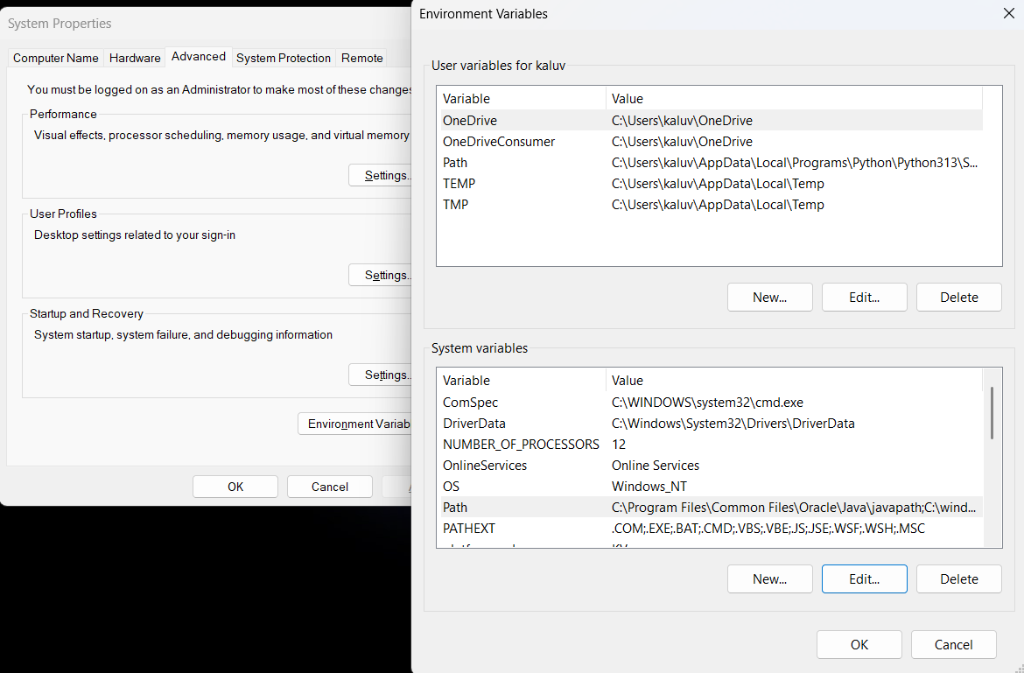

**Checking JDK Version: -**

* 1. **Open Command Prompt:**
* Presswin+R, typecmd, and press Enter.
  1. **Check Version:**
* Type java -version and press Enter.
* Type javac --version and press Enter.

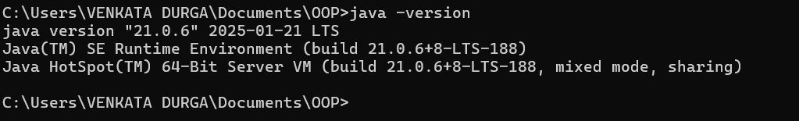

**2)**

**AIM:**

**Simple Java Program for printing Name, Class, Roll No, of a Student**

Write your code in Notepad and execute it in cmd prompt

**CODE: -**

class Main

{

public static void main(String[] args)

{

System.out.println("Name:k.v.durga prasad");

System.out.println("Class:CSE-B");

System.out.println("Roll No:24140");

}

}

**Output: -**

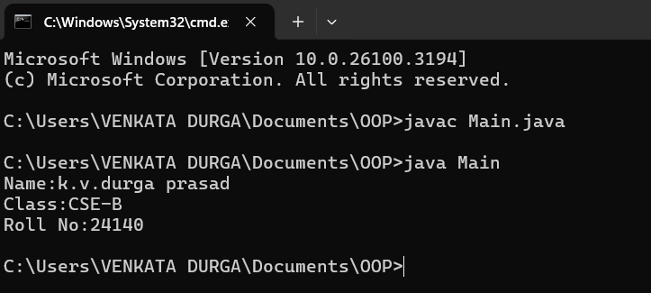

|  |  |  |
| --- | --- | --- |
| 1 | Syntax error | Semicolon added |
| 2 | Runtime error | Copied correct path |
| 3 | Name error | rectified |

Week-2

**1)**

**AIM ;**

**Simple Java Program for finding simple interest by taking input from**

**User**

**Code:**

**import java.util.Scanner;**

**class Main {**

**public static void main(String[] args) {**

**Scanner input = new Scanner(System.in);**

**System.out.print("Enter the principal: ");**

**double principal = input.nextDouble();**

**System.out.print("Enter the rate: ");**

**double rate = input.nextDouble();**

**System.out.print("Enter the time: ");**

**double time = input.nextDouble();**

**double interest = (principal * time * rate) / 100;**

**System.out.println("Principal: " + principal);**

**System.out.println("Interest Rate: " + rate);**

**System.out.println("Time Duration: " + time);**

**System.out.println("Simple Interest: " + interest);**

**input.close();**

**}**

**}**

**Output**

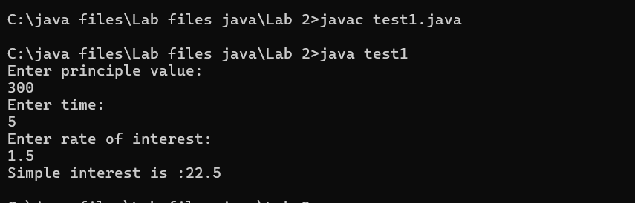

|  |  |  |  |
| --- | --- | --- | --- |
| **S.No** | **Error type** | **Reason for error** | **rectification** |
| **1** | **Runtime error** | **Incorrect path** | **Copied correct path** |
| **2** | **Syntax error** | **{ missing** | **{ added** |
| **3** | **Logical error** | **Wrong formula** | **Formula rectified** |

**2)**

**AIM:**

**Write a simple program to calculate factorial of a number and read the**

**input from user**

**code:**

**class Test {**

**static int factorial(int n)**

**{**

**int res = 1, i;**

**for (i = 2; i <= n; i++)**

**res *= i;**

**return res;**

**}**

**public static void main(String[] args)**

**{**

**int num = 5;**

**System.out.println("Factorial of " + num + " is "**

**+ factorial(5));**

**}**

**}**

**Output**

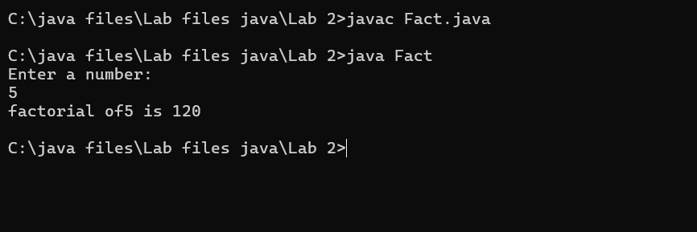

|  |  |  |  |
| --- | --- | --- | --- |
| **S.No** | **Error type** | **Reason for error** | **Rectification** |
| **1** | **Undeclared variable error** | **Missing variable** | **Variable declared** |
| **2** | **Missing import statement** | **Not importing packages** | **Packages imported** |
| **3** | **Logical error** | **Wrong formula** | **Formula rectified** |

**3)**

**AIM:**

**Write a program to to calculate the fibonacii sequence and take the input from user**

**Code:**

**import java.util.*;**

**class fibo**

**{**

**public static void main(String args[])**

**{**

**Scanner sc = new Scanner(System.in);**

**int num;**

**int f3;**

**int f1 = 0;**

**int f2 = 1;**

**int i = 2;**

**System.out.print("Enter a number:");**

**num = sc.nextInt();**

**System.out.println(f1);**

**System.out.println(f2);**

**while(i<num)**

**{**

**f3 = f1+f2;**

**f1 = f2;**

**f2 = f3;**

**System.out.println(f3);**

**i = i+1;**

**}**

**}**

**}**

**Output:**

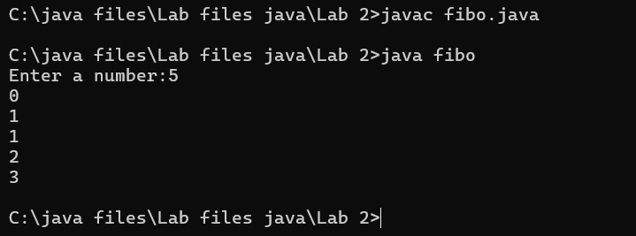

|  |  |  |  |
| --- | --- | --- | --- |
| **S.No** | **Error type** | **Reason for error** | **Rectification** |
| **1** | **Logical error** | **Incorrect formula** | **Formula rectified** |
| **2** | **Run-time error** | **Incorrect path** | **Added correct path** |
|  |  |  |  |

**4)AIM;**

**Write a java program to convert temperature from Fahrenheit to celsius**

**Code:**

**class Geeks {**

**public static void main(String[] args)**

**{**

**double f = 50.0, c = 0.0;**

**c = (f - 32) / 1.8;**

**System.out.println(**

**"value of temperature in celsius:" + c);**

**}**

**}**

**Output:**

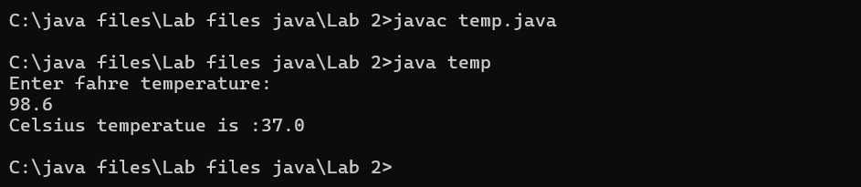

|  |  |  |  |
| --- | --- | --- | --- |
| **S.No** | **Error type** | **Reason for error** | **rectification** |
| **1** | **Syntax error** | **Missing ”** | **“ is added** |
| **2** | **Missing import error** | **Util package missing** | **Util package added** |
|  |  |  |  |

**5)AIM:**

**Write a java program to convert temperature from Celsius to Fahrenheit**

**Code:**

**class celsiustofahrenheit {**

**public static void main(String[] args)**

**{**

**double celsius = 10.0, fahrenheit = 0.0;**

**fahrenheit = (celsius * 1.8) + 32;**

**System.out.println(**

**" value of temperature in fahrenheit:"**

**+ fahrenheit);**

**}**

**}**

**Output:**

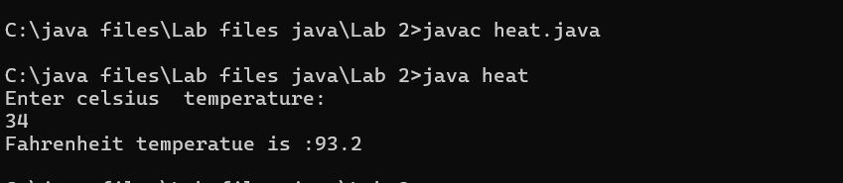

|  |  |  |  |
| --- | --- | --- | --- |
| **S.No** | **Error type** | **Reason for error** | **Rectification** |
| **1** | **Runtime error** | **Incorrect path selection** | **Correct path added** |
| **2** | **Logical error** | **Incorrect logic** | **Correct logic** |
|  |  |  |  |

**6)AIM:**

**Write a simple program to find the area of rectangle:**

**Code:**

**import java.util.*;**

**class Area{**

**public static void main(String[] args) {**

**int area;**

**Scanner sc = new Scanner(System.in);**

**System.out.println("Enter Length:");**

**int l = sc.nextInt();**

**System.out.println("Enter Breadth:");**

**int b = sc.nextInt();**

**area = l*b;**

**System.out.println("Area of Rectangle :"+area);**

**}**

**}**

**Output:**

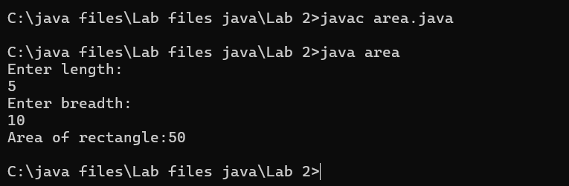

|  |  |  |  |
| --- | --- | --- | --- |
| **S.No** | **Error type** | **Reason for error** | **Rectification** |
| **1** | **Syntax error** | **Semi colon missing** | **Semi colon added** |
| **2** | **Missing import error** | **Import package missing** | **Import package added** |
|  |  |  |  |

**7)AIM:**

**Write a program to find the area of triangle by using heron’s formula**

**take the input from the user**

**Code:**

**port java.io.*;**

**class GFG {**

**static double area(double h, double b)**

**{**

**return (h * b) / 2;**

**}**

**public static void main(String[] args)**

**{**

**double h = 10;**

**double b = 5;**

**System.out.println("Area of the triangle: "**

**+ area(h, b));**

**}**

**}**

**Output:**

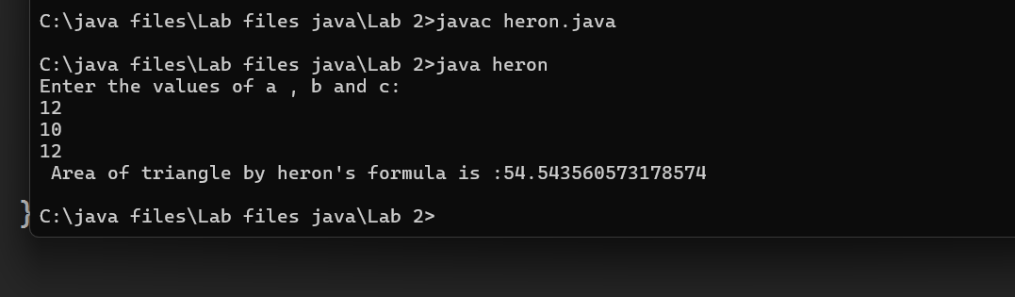

|  |  |  |  |
| --- | --- | --- | --- |
| **S.No** | **Error type** | **Reason for error** | **Rectification** |
| **1** | **Logical error** | **Incorrect formula** | **Formula rectified** |
| **2** | **Name error** | **Undeclared variable** | **Variable declared** |
|  |  |  |  |

**WEEK 3**

**Aim:**

**To create java program with following instructions**

**1.Create a class with name car**

**2. Create four attributes named car_color ,Car_brand,fuel_type,mileage**

**3. Create three methods named start(), stop(). Service()**

**4. Create three objects named car1,car2 and car3**

**Code:**

**import java.util.*;**

**class car**

**{**

**public String Car_color;**

**public String Car_brand;**

**public String fuel_type;**

**public int mileage;**

**public void start()**

**{**

**System.out.println("Car Started:");**

**System.out.println("Car color is :"+Car_color);**

**System.out.println("Car Brand is:"+Car_brand);**

**System.out.println("Car fuel type is:"+fuel_type);**

**System.out.println("Car mileage is:"+mileage);**

**}**

**public void service()**

**{**

**System.out.println("Car Started:");**

**System.out.println("Car color is :"+Car_color);**

**System.out.println("Car Brand is:"+Car_brand);**

**System.out.println("Car fuel type is:"+fuel_type);**

**System.out.println("Car mileage is:"+mileage);**

**}**

**public void stop()**

**{**

**System.out.println("Car Started:");**

**System.out.println("Car color is :"+Car_color);**

**System.out.println("Car Brand is:"+Car_brand);**

**System.out.println("Car fuel type is:"+fuel_type);**

**System.out.println("Car mileage is:"+mileage);**

**}**

**public static void main(String args[])**

**{ System.out.println("\n durga prasad\n\n");**

**car car1 = new car();**

**car1.Car_color = "Blue";**

**car1.Car_brand = "BMW";**

**car1.fuel_type = "Deisel";**

**car1.mileage = 10;**

**car1.start();**

**car car2 = new car();**

**car2.Car_color = "Red";**

**car2.Car_brand = "Tesla";**

**car2.fuel_type = "EV";**

**car2.mileage = 300;**

**car2.stop();**

**car car3 = new car();**

**car3.Car_color = "Yellow";**

**car3.Car_brand = "MAHINDRA";**

**car3.fuel_type = "Petrol";**

**car3.mileage = 20;**

**car3.service();**

**}**

**}**

**Output:**

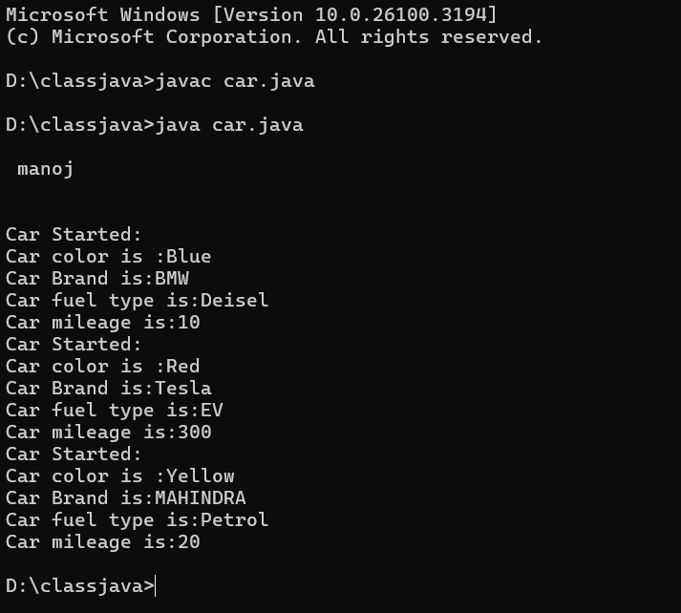

Class Diagram

|  |
| --- |
| Car |
| + car_color: String  + car_brand: String  + fuel_type: String  + mileage: int |
| + Car(): void  + start(): void  + service(): void  + stop(): void |

**Concepts to be known:**

1. public String car_color; - Used to declare a variable named car_color, with data type as String with public accessibility.
2. Car(String car_color,String car_brand,String fuel_type,int mileage){ } – It is a constructor (method with name same as class), which requires parameters such as car_color (String data-type) and so on.
3. this.car_color=car_color; - “this” is a default method, which is used to point to the instance variables.
4. public void start(){} – used to declare a method, which will return nothing(void) in public accessibility.
5. Car car1=new Car("Red","Maruti","Diesel",20); - used to create a object in class Car, with object name as car1.

car1.start(); - Calling a method, under object car1.

**2.)**

**AIM:**

**To create a class bankAccount with methods deposit() and withdrawl**

**Code:**

**class BankAccount**

**{**

**private double balance;**

**public BankAccount(double initialBalance)**

**{**

**if(initialBalance > 0)**

**{**

**this.balance = initialBalance;**

**}**

**else**

**{**

**this.balance = 0;**

**}**

**}**

**public void deposit(double amount)**

**{**

**if(amount>0)**

**{**

**balance = balance+amount;**

**System.out.println("Deposited $:"+amount);**

**}**

**else**

**{**

**System.out.println("Deposited amount must be positive");**

**}**

**}**

**public double getBalance()**

**{**

**return balance;**

**}**

**}**

**public class Main1**

**{**

**public static void main(String args[])**

**{**

**BankAccount account = new BankAccount(1000);**

**account.deposit(500);**

**System.out.println("Current Balance is:"+account.getBalance());**

**}**

**}**

**Output:**

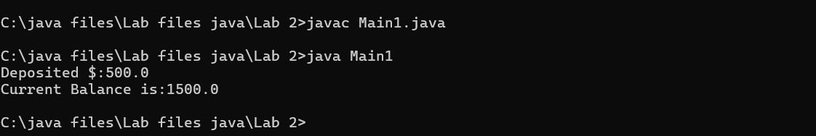

**ERRORS:**

|  |  |  |
| --- | --- | --- |
| **Sno.** | **Error message** | **Error rectification** |
| 1. | error: ';' expected  cust1.withdraw(3050) | Add a “;”    cust1.withdraw(3050); |
| 2. | error: cannot find  symbol  thisCurrBal=CurrBal; | Add a “.”    this.CurrBal=CurrBal; |

**Concepts to be known:**

1. private String name; - Used to declare a variable named name, with data type as String with private accessibility.
2. BankAccount(String name,int Accno,int CurrBal){ } – It is a constructor (method with name same as class), which requires parameters such as name (String data-type) and so on.
3. this.CurrBal=CurrBal; - “this” is a default method, which is used to point to the instance variables.
4. public void withdraw(int WAmt){ } – used to declare a method, which will return nothing(void) in public accessibility, which requires a parameter WAmt(integer data type).
5. public int deposit(int DAmt){} - used to declare a method, which will return integer data type in public accessibility, which requires a parameter DAmt(integer data type).
6. BankAccount cust1=new BankAccount("Ram",5587,20000); - used to create a object in class BankAccount, with object name as cust1.
7. cust1.withdraw(50000); - Calling a method, under object cust1, by passing a parameter.

System.out.println("Your current balance after depositing money is:"+cust1.deposit(25000)); - Deposit method will return the value, which will be directly printed.

WEEK-4

**1.AIM:**

**WRITE A JAVA PROGRAM WITH CLASS NAMED “Book”. THE CLASS SHOUKD CONTAIN VARIOUS ATTRIBUTES SUCH AS TITLE, AUTHOR, YEAR OF**

**PUBLICATION. IT SHOULD ALSO CONTAIN A CONSTRUCTOR WITH**

**PARAMETERS WHICH INITIALIZES TITLE, AUTHOR, YEAR OF PUBLICATION**

**AND CREATE A METHOD WHICH DISPLAYS THE DETAILS OF 2 BOOKS.**

**PROGRAM:**

**public class Book {**

**public String title;**

**public String author;**

**public int year;**

**Book(String title, String author, int year) {**

**this.title = title;**

**this.author = author;**

**this.year = year;**

**}**

**public void displayDetails() {**

**System.out.println("Title: " +title);**

**System.out.println("Author: " +author);**

**System.out.println("Year of Publication" +year);**

**}**

**public static void main(String[] args) {**

**Book b1 = new Book("Math", "Ramanujan", 1950);**

**Book b2 = new Book("Physics", "CV Raman", 1960);**

**b1.displayDetails();**

**b2.displayDetails();**

**}**

**}**

**Output:**

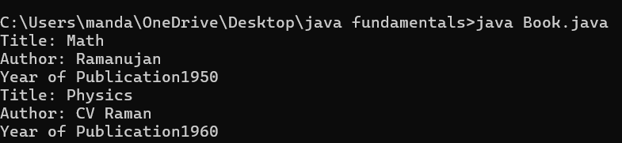

**NEGATIVE CASE:**

**ERROR:**

|  |  |  |  |
| --- | --- | --- | --- |
| **S.No** | **ERROR TYPE** | **Reason for error** | **Rectification** |
| **1.** | Syntax error | No semicolon | Semicolon added |
| **2.** | Runtime error | Incorrect path | Copied correct path |

**CLASS DIAGRAM:**

|  |
| --- |
| Book |
| -title: String  -author: String  -year: int |
| + Book(title: String, author:String, year: int) + displayDetails(): void |

**IMPORTANT POINTS:**

1. **Constructor**:

* The constructor Book(String, String, int) is used to initialize the object when it is created.
* The keyword **this** is used to differentiate between class attributes and constructor parameters.

2.**Method**:

* The method displayDetails() is used to display the book details.
* The **System.out.println()** method prints the details to the console.

3. **Object Creation**:

* Two objects b1 and b2 are created using the constructor.

**2.AIM:**

**WRITE A JAVA PROGRAM WITH CLASS NAMED “MyClass” WITH A STATIC VARIABLE COUNT OF INT TYPE. INTIALIZE IT TO ZERO AND A CONSTANT VARIABLE “Pi” OF TYPE DOUBLE INITIALIZED TO “3.14” AS ATTRIBUTES OF THAT CLASS. NOW DEFINE A CONSTRUCTOR FOR “MyClass”, THAT INCREMENTS THE COUNT VARIABLE EACH TIME AN OBJECT OF “MyClass” IS CREATED. FINALLY, PRINT THE FINAL VALUES OF ‘COUNT’ AND ‘PI’ VARIABLES AND CREATE 3 OBJECTS.**

**PROGRAM:**

public class MyClass {

static int count = 0;

static final double pi = 3.14;

MyClass() {

count++;

}

public static void main(String[] args) {

MyClass obj1 = new MyClass();

MyClass obj2 = new MyClass();

MyClass obj3 = new MyClass();

System.out.println("Count: " +count);

System.out.println("Pi: " +pi);

}

}

**OUTPUT:**

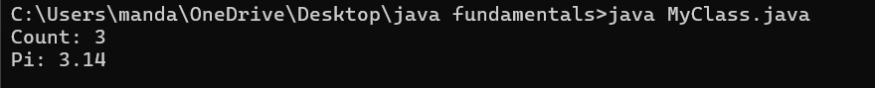

**NEGATIVE CASE:**



**ERROR:**

|  |  |  |  |
| --- | --- | --- | --- |
| **S.No** | **Error Type** | **Reason for error** | **Rectification** |
| **1.** | No class | No class name declared | Created class named ‘MyClass’ |
| **2.** | Syntax error | Not added keyword | Added keyword named ‘new’ |

**CLASS DIAGRAM:**

|  |
| --- |
| MyClass |
| -count: int (static)  -pi: double (static, final) |
| +MyClass()  +main(args: String[]):void |

**IMPORTANT POINTS:**

**1.Static Keyword**

* Static members belong to the **class, not to individual objects**.
* Only one copy of the static variable is maintained for all objects.

**2.Static Variable**

* **static int count**:
  + Shared among all objects of the class.
  + It is initialized only once and not for every object.
  + It increments every time the constructor is called.

**3.Final Variable**

* **static final double pi**:
  + The **final** keyword makes the variable constant.
  + Its value **cannot be changed** once assigned.
  + It must be initialized at the time of declaration.

**Week-5**

**1)Aim :** create a calculator using the operations including addition, subtraction, multiplication and division using multilevel inheritance and display the desired output .

**Program :**

public class calculator {

    int a = 18;

    int b = 1;

void addition(){

    System.out.println("Addition is :" + (a+b));

}

}

class multi1 extends calculator{

    void subtraction(){

        System.out.println("Subtraction is :" + (a-b));

    }

}

class multi2 extends calculator{

    void multiplication(){

        System.out.println("Multiplication is :" + (a*b));

    }

}

class multi3 extends calculator{

    void division(){

        System.out.println("Division is :" + (a/b));

    }

}

class multipleinheritance {

    public static void main(String[] args) {

        multi1 m1 = new multi1();

        multi2 m2 = new multi2();

        multi3 m3 = new multi3();

        m1.addition();

        System.out.println("    ");

        m1.subtraction();

        System.out.println("    ");

        m2.multiplication();

        System.out.println("    ");

        m3.division();

}

}

**OUTPUT :**

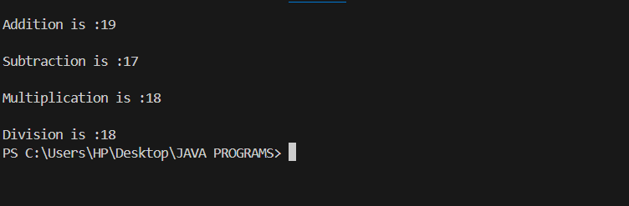

**ERROR :**

|  |  |  |  |
| --- | --- | --- | --- |
| **S.No** | **Error type** | **Reason for error** | **Rectification** |
| 1 | syntax error | String forgot in main function | String is added |
| 2 | Logical error | Incorrect logic | Correct logic |

**2)** **Aim:** A vehicle rental company wants to develop a system that maintains information about different types of vehicles available for rent. The company rents out cars and bikes and they need a program to store details about each variable such as brand and speed.

• Cars should have an additional property: numbers of doors, seating capacity.

• Bikes should have a property indicating whether they have gears or not.

• The system should also include a function to display details about each vehicle & indicates when a vehicle is starting.

• Every class should have constructor.

1. Which OOP concept is used in the above program? Explain why it is useful in this scenario.

2. If the company decides to add a new type of vehicle: Truck, how would you modify the program?

• Truck should include an additional property capacity(in tons)

• Create a ShowTruckDetails() method to display the truck’s capacity.

• Write a constructor for Truck that initializes all properties.

3)Aim: Implement the truck class and update the main method to create a truck object & also create an object for car & bike sub classed. Finally display its details

**Program :**

class Vehicle{

    String brand;

    int speed;

    Vehicle(String brand,int speed){

        this.brand=brand;

        this.speed=speed;

    }

    void Details(){

        System.out.println("Brand:"+brand);

        System.out.println("Speed:"+speed);

    }

}

class CARS extends Vehicle{

    int doors;

    int capacity;

    public CARS(String brand,int speed,int doors,int capacity){

        super(brand, speed);

        this.doors=doors;

        this.capacity=capacity;

    }

    void cardetails(){

        System.out.println("Number of doors:"+doors);

        System.out.println("Capacity:"+capacity);

    }

}

class Bikes extends Vehicle{

    Boolean gears;

    Bikes(String brand,int speed,Boolean gears){

        super(brand, speed);

        this.gears=gears;

    }

    void bikedetails(){

        if (gears==true)

        System.out.println("This bike has gears.");

        else

        System.out.println("This bike does not have gear system.");

    }

}

class Trucks extends Vehicle{

    int tons;

    Trucks(String brand,int speed,int tons){

        super(brand, speed);

        this.tons=tons;

    }

    void truckdetails(){

        System.out.println("The capacity of truck is: "+tons);

    }

}

class Rent{

    public static void main(String[] args){

        CARS c=new CARS("Tayota",120,5,5);

        c.cardetails();

        c.Details();

        Bikes b=new Bikes("KTM",80,true);

        b.bikedetails();

        b.Details();

        Trucks t=new Trucks("TATA",100,1);

        t.truckdetails();

        t.Details();

    }

}

**OUTPUT :**

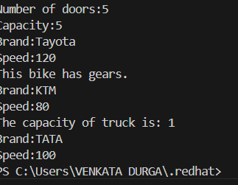

**ERROR :**

|  |  |  |  |
| --- | --- | --- | --- |
| **S.No** | **Error type** | **Reason for error** | **Rectification** |
| 1 | syntax error | String forgot in main function | String is added |
| 2 | Logical error | Incorrect logic | Correct logic |

**WEEK - 6**

1. **Aim : Write a Java program to create a Vehicle class with a method displayInfo(). Override this method in the Car subclass to provide specific information about a car.**

**Program :**

class vehicle{

    String company;

    String model;

    String fuel;

    int capacity;

    void displayInfo(String company,String model,String fuel,int capacity){

        System.out.println("The details of vehicle: ");

        this.company=company;

        this.model=model;

        this.fuel=fuel;

        this.capacity=capacity;

    }

}

class car extends vehicle{

    void displayInfo(String company,String model,String fuel,int capacity){

        System.out.println("Company: "+company);

        System.out.println("Model: "+model);

        System.out.println("Fuel: "+fuel);

        System.out.println("Capacity: "+capacity);

    }

}

class poly1{

    public static void main(String[] args){

        car car1=new car();

        car1.displayInfo("Audi","Model","Diesel",4);

    }

}

**OUTPUT :**

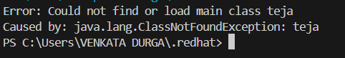

**ERRORS :**

|  |  |  |  |
| --- | --- | --- | --- |
| **S.No** | **Error type** | **Reason for error** | **Rectification** |
| 1 | Syntax error | [] is missed | [] is added |
| 2 | Logical error | Incorrect logic | Correct logic |

**2) Aim :** A college is developing an automated admission system that verifies students' eligibility for undergraduate (UG) and postgraduate (PG) programs. Each program has different eligibility criteria based on the students' percentage in their previous qualifications.

(i)UG admissions require a minimum of 60%.

(ii)PG admissions require a minimum of 70%

**Program :**

class College{

    String name;

    int percentage;

    void geteligibility(String name,int percentage){

        this.name=name;

        this.percentage=percentage;

    }

}

class UG extends College{

    void geteligibility(String name,int percentage){

        if (percentage>=60){

            System.out.println(name+" is eligible");

        }

        else{

            System.out.println(name+" is not eligible");

        }

    }

}

class PG extends College{

    void geteligibility(String name,int percentage){

        if (percentage>=70){

            System.out.println(name+" is eligible");

        }

        else{

            System.out.println(name+" is not eligible");

        }

    }

}

class poly2{

    public static void main(String[] args){

        UG ug=new UG();

        ug.geteligibility("Person-1",40);

        PG pg=new PG();

        pg.geteligibility("Person-2",80);

    }

}

**OUPUT :**

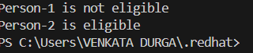

**ERROR :**

|  |  |  |  |
| --- | --- | --- | --- |
| **S.No** | **Error type** | **Reason for error** | **Rectification** |
| 1 | syntax error | String forgot in main function | String is added |
| 2 | Logical error | Incorrect logic | Correct logic |

**3) Aim :** Create a Calculator class with overloaded methods to perform addition:

(i) Add two integers.

(ii) Add two doubles.

(iii) Add three integers.

**Program :**

class Calcee{

    public int add(int a,int b){

        return a+b;

    }

    public double add(double a,double b){

        return a+b;

    }

    public int add(int a,int b,int c){

        return a+b+c;

    }

}

class poly3{

    public static void main(String[] args){

        Calcee C1=new Calcee();

        System.out.println("Sum of 2 and 5 is: "+C1.add(2,5));

        System.out.println("Sum of 3.2 and 6.5 is: "+C1.add(3.2,6.5));

        System.out.println("Sum of 2,5 and 3 is: "+C1.add(2,5,3));

    }

}

**OUTPUT :**

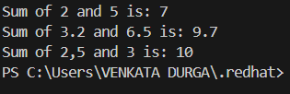

**ERROR :**

|  |  |  |  |
| --- | --- | --- | --- |
| **S.No** | **Error type** | **Reason for error** | **Rectification** |
| 1 | syntax error | String forgot in main function | String is added |
| 2 | Logical error | Incorrect logic | Correct logic |

**4)Aim :** Create a Shape class with a method calculateArea() that is overloaded for different shapes (e.g., square, rectangle). Then, create a subclass Circle that overrides the calculateArea() method for a circle.

**Program :**

class Shape { // class shape

    void calculateArea( int a) { // method 1

        System.out.println("The area of Square is :" + (a*a) );

    }

    void calculateArea(int a , int b) { // method 2

        System.out.println("The area of rectangle is :" + (a*b));

    }

}

class circle extends Shape { // inheritance class

    void calculateArea(double a){ // method overloading

        System.out.println("The area of circle is :" + (3.14*a*a));

  } }

class main { // main program

    public static void main(String[] args) {

        // creating objects for class

        Shape s = new Shape();

        circle c = new circle();

        // calling methods

        s.calculateArea(4);

        System.out.println("    ");

        s.calculateArea(4, 5);

        System.out.println("    ");

        c.calculateArea(2);

    }

}

**OUTPUT :**

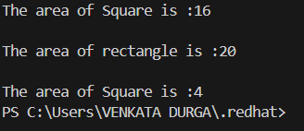

**ERRORS :**

|  |  |  |  |
| --- | --- | --- | --- |
| **S.No** | **Error type** | **Reason for error** | **Rectification** |
| 1 | Syntax error | ; is missed | ; is added |
| 2 | Logical error | Incorrect logic | Correct logic |

**WEEK-7**

1. **Aim: Write a Java program to create an abstract class Animal with an abstract method called sound(). Create subclasses Lion and Tiger that extend the Animal class and implement the sound() method to make a specific sound for each animal.**

**PROGRAM:**

**abstract class Animal { // abstract class**

**abstract void sound(); // abstract method**

**}**

**class Lion extends Animal { // Sub class**

**void sound() {**

**System.out.println("Lion Roar...!"); // sub class method to override the abstract method**

**}**

**}**

**class Tiger extends Animal {**

**void sound() {**

**System.out.println("Tiger Roar...!"); // sub class method to override the abstract method**

**}**

**}**

**class Sound { // main program**

**public static void main(String[] args) {**

**//Creating objects for the sub classes**

**Lion l = new Lion();**

**Tiger t = new Tiger();**

**System.out.println("Name : K .v.durga prasad"  + "Roll No : AV.SC.U4CSE24140" + "Section : CSE-B");**

**System.out.println("    ");**

**l.sound(); // calling sub class method**

**System.out.println("    ");**

**t.sound();// calling sub class method**

**}**

**}**

**OUTPUT:**

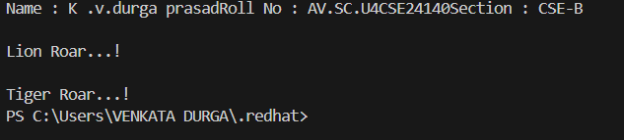

**ERRORS:**

|  |  |  |  |
| --- | --- | --- | --- |
| **S.No** | **Error type** | **Reason for error** | **Rectification** |
| **1** | **Syntax error** | **Abstract key word is missed before method** | **Abstract keyword is added** |
| **2** | **Logical error** | **Incorrect logic in subclass method** | **Corrected logic in subclass method** |

**2)Aim : Write a Java program to create an abstract class Shape3D with abstract methods calculateVolume() and calculateSurfaceArea(). Create subclasses Sphere and Cube that extend the Shape3D class and implement the respective methods to calculate the volume and surface area of each shape.**

**PROGRAM :**

**import java.math.*; //pacakage importing**

**abstract class Shapes3D { //abstract class**

**abstract void CalculateVolume(); // abstract method**

**abstract void CalculateSurfaceArea(); // abstract method**

**}**

**class Sphere extends Shapes3D { //Sub class extends abstract class**

**int radius;**

**Sphere(int radius) { // sub class Constructor**

**this.radius = radius;**

**}**

**void CalculateVolume() {**

**System.out.println("Volume of sphere is: " + (4.0 / 3.0) * Math.PI * radius * radius * radius);**

**}**

**void CalculateSurfaceArea() {**

**System.out.println("Surface area of sphere is: " + 4 * Math.PI * radius * radius);**

**}**

**}**

**class Cube extends Shapes3D {//Sub class extends abstract class**

**int side;**

**Cube(int side) { // sub class Constructor**

**this.side = side;**

**}**

**void CalculateVolume() {**

**System.out.println("Volume of cube is: " + side * side * side);**

**}**

**void CalculateSurfaceArea() {**

**System.out.println("Surface area of cube is: " + 6 * side * side);**

**}**

**}**

**public class Shapes18 {**

**public static void main(String[] args) {**

**Sphere sp = new Sphere(5);**

**Cube c = new Cube(4);**

**System.out.println("Name : K.v.durga prasad Section : CSE-B  Roll no : AV.SC.U4CSE24140\n");**

**System.out.println("    ");**

**sp.CalculateSurfaceArea();**

**System.out.println("    ");**

**sp.CalculateVolume();**

**System.out.println("    ");**

**c.CalculateSurfaceArea();**

**System.out.println("    ");**

**c.CalculateVolume();**

**}**

**}**

**OUTPUT:**



**ERROR:**

|  |  |  |  |
| --- | --- | --- | --- |
| **S.No** | **Error type** | **Reason for error** | **Rectification** |
| **1** | **Syntax error** | **package is missed before abstract class** | **Package is imported** |
| **2** | **Logical error** | **Incorrect logic in subclass method** | **Corrected logic in subclass method** |

**3)Aim : Write a java program using an abstract class to define a method for pattern printing Create an abstract class named pattern printer with an abstract method printpattern(int n) and a concrete method to display the pattern title.**

**Implement two subclasses:**

**1) Star pattern - Prints a right-angled triangle of stars(*).**

**2) Number pattern - Prints a right- angled triangles of increasing numbers.**

**In the main() method, create Objects**

**Star Pattern Number pattern**

**\* 1**

**\*\* 1 2**

**\*\*\* 1 2 3**

**\*\*\*\* 1 2 3 4**

**\*\*\*\*\* 1 2 3 4 5**

**PROGRAM :**

**abstract class PatternPrinter { // abstract class**

**abstract void printPattern(int n); // abstract method**

**void displayTitle(String title) {**

**System.out.println(title);**

**}**

**}**

**class StarPattern extends PatternPrinter { // Star pattern subclass**

**void printPattern(int n) {**

**for (int i = 1; i <= n; i++) {**

**for (int j = 1; j <= i; j++) {**

**System.out.print("* ");**

**}**

**System.out.println();**

**}**

**}**

**}**

**class NumberPattern extends PatternPrinter {// Number pattern subclass**

**void printPattern(int n) {**

**for (int i = 1; i <= n; i++) {**

**for (int j = 1; j <= i; j++) {**

**System.out.print(j + " ");**

**}**

**System.out.println();**

**}**

**}**

**}**

**class PatternProgram { //Main program**

**public static void main(String[] args) {**

**//  creating objects for Star & Number pattern classes**

**StarPattern sp = new StarPattern();**

**NumberPattern np = new NumberPattern();**

**System.out.println("Name:K.v.durga prasad  Roll no:AV.SC.U4CSE24140 Section:CSE-B");**

**System.out.println("    ");**

**sp.displayTitle("Star Pattern");**

**sp.printPattern(5);**

**System.out.println("    ");**

**np.displayTitle("Number Pattern");**

**np.printPattern(5);**

**}**

**}**

**OUTPUT:**

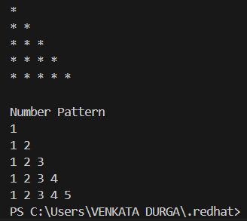

**ERROR:**

|  |  |  |  |
| --- | --- | --- | --- |
| **S.No** | **Error type** | **Reason for error** | **Rectification** |
| **1** | **Syntax error** | **For loop increment condition is missed in subclass method** | **Increment condition is added in subclass method** |
| **2** | **Logical error** | **Incorrect logic in subclass method** | **Corrected logic in subclass method** |

**WEEK-8**

1. **Aim :** Write a Java program to create an interface Shape with the getPerimeter() method. Create three classes Rectangle, Circle, and Triangle that implement the Shape interface. Implement the getPerimeter() method for each of the three classes.

**PROGRAM :**

interface Shape {

    double getPerimeter();

}

class Rectangle implements Shape {

    private double length;

    private double width;

    public Rectangle(double length, double width) {

        this.length = length;

        this.width = width;

    }

    public double getPerimeter() {

        return 2 * (length + width);

    }

}

class Circle implements Shape {

    private double radius;

    public Circle(double radius) {

        this.radius = radius;

    }

    public double getPerimeter() {

        return 2 * Math.PI * radius;

    }

}

class Triangle implements Shape {

    private double side1;

    private double side2;

    private double side3;

    public Triangle(double side1, double side2, double side3) {

        this.side1 = side1;

        this.side2 = side2;

        this.side3 = side3;

    }

    public double getPerimeter() {

        return side1 + side2 + side3;

    }

}

public class Perimeter {

    public static void main(String[] args) {

        Shape rectangle = new Rectangle(5, 3);

        Shape circle = new Circle(4);

        Shape triangle = new Triangle(3, 4, 5);

        System.out.println("Name:K.v.durga prasad

Roll no:AV.SC.U4CSE24140  Section:CSE-B");

        System.out.println("    ");

        System.out.println("Rectangle perimeter: " + rectangle.getPerimeter());

        System.out.println("Circle perimeter: " + circle.getPerimeter());

        System.out.println("Triangle perimeter: " + triangle.getPerimeter());

    }

}

**OUTPUT:**

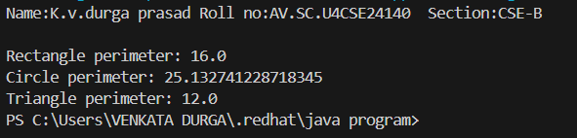

**ERRORS:**

|  |  |  |  |
| --- | --- | --- | --- |
| **S.No** | **Error type** | **Reason for error** | **Rectification** |
| 1 | Syntax error | Used extends keyword instead of implements keyword in inheritance | Implements key word is added in inheritance |

**2)Aim:** Write a Java program to create an interface Playable with a

ethod play() that takes no arguments and returns void. Create three classes Football, Volleyball, and Basketball that implement the

Playable interface and override the play() method to play the

respective sports.

**PROGRAM:**

interface Playable {

    void play();

    public static void main(String[] args) {

        Playable football = new Football();

        Playable volleyball = new Volleyball();

        Playable basketball = new Basketball();

        football.play();

        volleyball.play();

        basketball.play();

        System.out.println("suvidh CSE24140 CSE-B");

    }

}

class Football implements Playable {

    public void play() {

        System.out.println("Playing Football");

    }

}

class Volleyball implements Playable {

    public void play() {

        System.out.println("Playing Volleyball");

    }

}

class Basketball implements Playable {

    public void play() {

        System.out.println("Playing Basketball");

    }

}

public class PlayableTest {

    public static void main(String[] args) {

        Playable football = new Football();

        Playable volleyball = new Volleyball();

        Playable basketball = new Basketball();

        System.out.println("Name: K.v.durga prasad  Roll no: AV.SC.U4CSE24140  Section:CSE-B");

        System.out.println("    ");

        football.play();

        System.out.println("    ");

        volleyball.play();

        System.out.println("    ");

        basketball.play();

    }

}

**OUTPUT:**

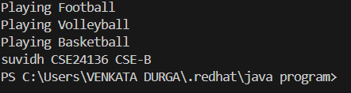

**ERROR:**

|  |  |  |  |
| --- | --- | --- | --- |
| **S.No** | **Error type** | **Reason for error** | **Rectification** |
| 1 | Syntax error | Error in calling play method in football class because object is not created for football class | Object created for football class |

**3)Aim:** write a java program to implement a login system using

interfaces.

**PROGRAM:**

interface LoginSystem {

    boolean Login(String ID, int pass);

}

class CollegePortal implements LoginSystem {

    public boolean Login(String ID, int pass) {

        if ((ID=="DURGA ") && (pass==24140)){

            System.out.println("Login Successful..!");

            return true;

        }else {

            System.out.println("Invalid ID or Password");

            return false;

        }

    }

}

class LoginPortal {

    public static void main(String[] args) {

        CollegePortal CP = new CollegePortal();

        System.out.println("Name: K.v.durga prasad Roll no: AV.SC.U4CSE24140  Section:CSE-B");

        System.out.println("    ");

        CP.Login("DURGA", 24140);

    }

}

**OUTPUT:**

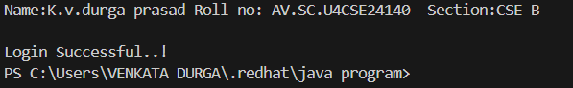

**ERROR:**

|  |  |  |  |
| --- | --- | --- | --- |
| **S.No** | **Error type** | **Reason for error** | **Rectification** |
| 1 | Syntax error | Error in If statement condition | If statement condition is corrected |